

**Lab Report**

**Course Title: Object Oriented Programming II Lab**

**Course Code: CSE222**

**Submitted To: Ms. Umme Ayman**

Department of CSE

Daffodil International University

**Submitted By:**

Name: MD. Tanvir Ahmed Akash

ID: 221-15-5424

Section: 61_M

Department of CSE

Daffodil International University

|  |
| --- |
| Submission Date: 18-02-2024 |

**Lab Task-01**

**Problem-01:** Suppose, you are working as a python programmer in a Software company.You are asked to create a python program which will take a String as an Input and rotate some of it’s characters to make a secure password.Now,

* You should take input string of ‘m’ size without whitespace.
* Take ‘n’ as the numbers of characters to rotate the string .
* Where n<=m

**Sample Input:**

Size of String m= 9

Input String:ummeAyman

Number of characters to rotate:05

**Solution:**

m = int(input("Enter Size of String: "))

userString= input("Input String: ")

n = int(input(" Enter Number of characters to rotate: "))

finalString = userString[n:] + userString[:n]

print("Rotated String is:", finalString)

**Output:**

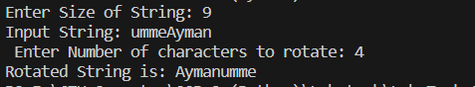

**Problem-02:** Suppose, you are a security engineer of an IT organization.You are asked to develop a system which converts the company’s Employees name into a numerical value to ensure Employees anonymity in terms of security enhancement.Now,

1. You take a list of employee name.
2. Find out the ASCII values of all Characters of each employee name.
3. Then, add the all ASCII values of each name as well as store that sum value in another list.

**Sample Input:**  EmployeeName:[“Umme” ,”Eity”, “Esrat”]

**Sample Output:** NumericalValues=[207,135,245]

**Solution:**

Names = input("Enter list of Names: ").split()

AddedNamesAscii_list = []

for name in Names:

    ascii_sum = 0

    for char in name:

        ascii_sum += ord(char)

    AddedNamesAscii_list.append(ascii_sum)

print("Numerical Values=", AddedNamesAscii_list)

**Output:**



**Lab Task-02**

**Problem-01:** Write a Python function that takes a list and returns a new list with unique elements from the first list.

**Solution:**

def is_unique_number(n):

    num_str = str(n)

    if len(num_str) == len(set(num_str)):

        return n

numbers = list(map(int, input("Enter a list of Numbers: ").split()))

uniqueNumbers = []

for num in numbers:

    unique_num = is_unique_number(num)

    if unique_num is not None:

        uniqueNumbers.append(unique_num)

print("Unique Elements Are :", uniqueNumbers)

**Output:**



**Problem-02:** Write a Python program to reverse print a list using recursion.

**Solution:**

def to_reverse_print(x):

    if not x:

        return

    to_reverse_print(x[1:])

    print(x[0])

List = list(map(int, input("Enter a list of Numbers: ").split()))

print("Reverse List is:")

to_reverse_print(List)

**Output:**

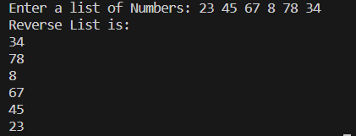

**Problem-03:** Write a function that inputs a number and prints the multiplication table of that number

**Solution:**

def multiplicationTable(num):

    for i in range(1, 11):

        print(f"{num} x {i} = {num * i}")

num=int(input("Enter Number: "))

multiplicationTable(num)

**Output:**

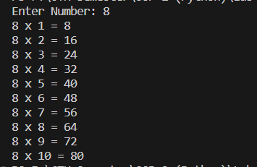

**Problem-04:** Write a program to reverse an integer number using for loop or while loop.

Example : 1435

Result : 5341

**Solution:**

def reverseInteger(num):

    reversed_num = 0

    while num > 0:

        digit = num % 10

        reversed_num = (reversed_num * 10) + digit

        num //= 10

    return reversed_num

num=int(input("Enter Number: "))

reveresdNum=reverseInteger(num)

print("Result:",reveresdNum)

**output:**



**Problem-05:** Write a python function that takes a string and checks if it’s palindrome or not.

Example : “madam” “cat”

Result : “Palindrome , not palindrome

**Solution:**

def palindromeCheck(mystring):

    return mystring == mystring[::-1]

mystring = input("Enter a string: ")

if palindromeCheck(mystring):

    print("Palindrome")

else:

    print("Not Palindrome")

**output:**





**Problem-06:** Write a python program where you will be given a list [5,2,4,3,2,3] and a target value 2 and you have to get the index of the list when the target value appears for the first time. (do it by user inputting the list and target value)

For example : here 2 occurs in [1] index for the first time.

**Solution:**

def indexFind(lst, key):

    for i, num in enumerate(lst):

        if num == key:

            return i

    return -1

numbers = list(map(int, input("Enter a list of Numbers: ").split()))

target_num = int(input("Enter Your Target Number: "))

res = indexFind(numbers, target_num)

if res != -1:

    print("Here,", target_num, "occurs in [", res+1, "] index for the first time.")

else:

    print("Your target number", target_num, " Not Found.")

**output:**



**Problem-07:** write a python function that takes a list and prints only the positive numbers from the list. Hint : (Can use the continue keyword)

**Solution:**

def positiveNumbers(numbers):

    for num in numbers:

        if num <= 0:

            continue

        print(num)

numbers = list(map(int, input("Enter a list of Numbers: ").split()))

print("Positive numbers Are:")

positiveNumbers(numbers)

**output:**

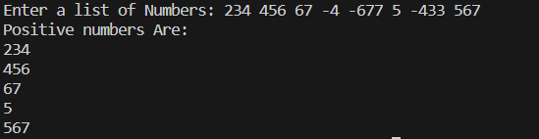

**Problem-08:** Write a recursive function that accepts a number as its argument and returns the sum of digits or you can use a loop to solve it.

Example : 2331

Output : 9

**Solution:**

def sum_Of_Digits(n):

    if n == 0:

        return 0

    return n % 10 + sum_Of_Digits(n // 10)

number = int(input("Enter a Number: "))

result = sum_Of_Digits(number)

print("Sum of digits:", result)

**output:**



**Problem-09:** Write a recursive function that takes in a list of integers, and returns the sum of only odd numbers inside the list.

**Solution:**

def odd_Sum(lst):

    sum = 0

    for num in lst:

        if num % 2 != 0:

            sum += num

    return sum

numbers = list(map(int, input("Enter a list of numbers: ").split()))

res = odd_Sum(numbers)

print("Sum of odd numbers:", res)

**output:**



**Problem-10:** Write a python program having two list and compare the values inside the list and make a new list with only the unique values and the new list must be sorted.

Example : [1,4,5,6,7] , [2,1,3,4,5] newlist = [2,3,6,7]

**Solution:**

def unique_numbers(list1, list2):

    set1 = set(list1)

    set2 = set(list2)

    unique_to_list1 = set1 - set2

    unique_to_list2 = set2 - set1

    return sorted(unique_to_list1.union(unique_to_list2))

list1 = list(map(int, input("Enter a list of Numbers: ").split()))

list2 = list(map(int, input("Enter a list of Numbers: ").split()))

new_list = unique_numbers(list1, list2)

print("Unique and Sorted List is:", " ".join(map(str, new_list)))

**output:**

